CH VACD Immunization Administration
FHIR to openEHR Mapping Documentation
Accompanying notes for the Excel mapping table and openEHR Template

1. Background and scope
As part of the GovTech Hackathon, openEHR Switzerland and HL7 Switzerland submitted a vaccination showcase as a challenge. The showcase uses concrete Swiss immunisation use cases to demonstrate how the two international standards HL7 FHIR and openEHR can complement each other: HL7 FHIR is used for interoperable exchange, while openEHR is used for long-term, structured persistence of clinical vaccination data.
In this architecture, administered vaccinations are transmitted using the HL7 FHIR CH VACD Immunization Administration Document: https://www.fhir.ch/ig/ch-vacd/immunization-administration-document.html
The vaccination data is then persisted in an openEHR Clinical Data Repository.
The showcase also supports the retrieval of administered vaccinations. In this scenario, all vaccinations persisted in the patient’s openEHR Clinical Data Repository are collected and transformed into an HL7 FHIR CH VACD Vaccination Record Document: https://www.fhir.ch/ig/ch-vacd/vaccination-record-document.html
The resulting FHIR documents are Bundles that include entries conforming to the FHIR CH VACD Immunization profile. The reverse mapping from openEHR to FHIR is therefore performed at the level of the CH VACD Immunization resource profile, and the resulting Immunization resources are then assembled into the CH VACD Vaccination Record Document for exchange.
For resource reasons, the scope of the showcase is deliberately limited. The implementation focuses on the Immunization Administration section of the CH VACD Immunization Administration Document and on the corresponding vaccination entries in the HL7 FHIR CH VACD Vaccination Record Document. More specifically, the mapping focuses on the FHIR CH VACD Immunization profile: https://www.fhir.ch/ig/ch-vacd/StructureDefinition-ch-vacd-immunization.html

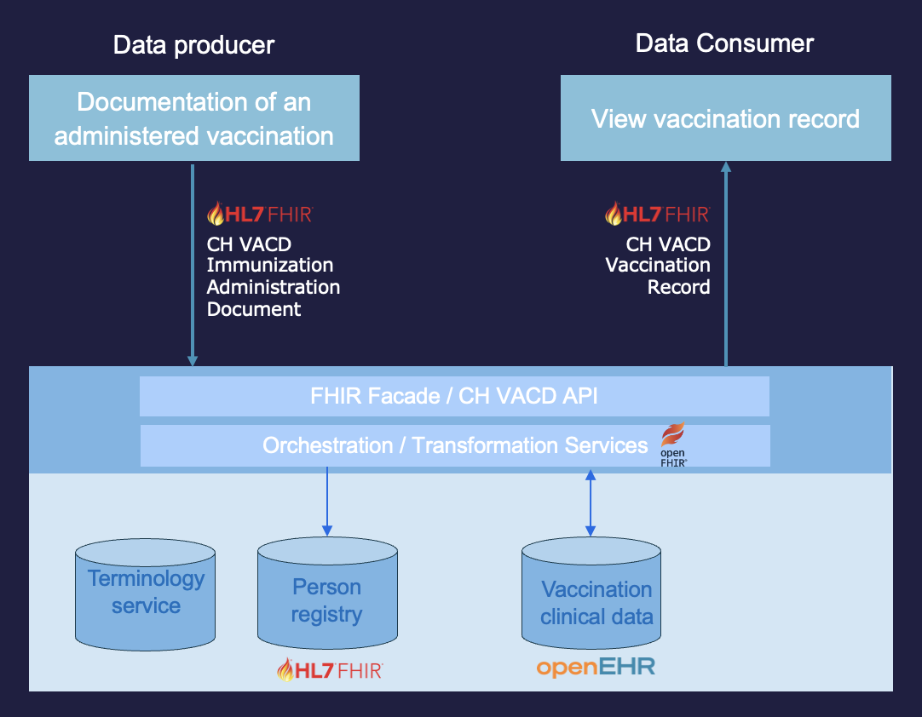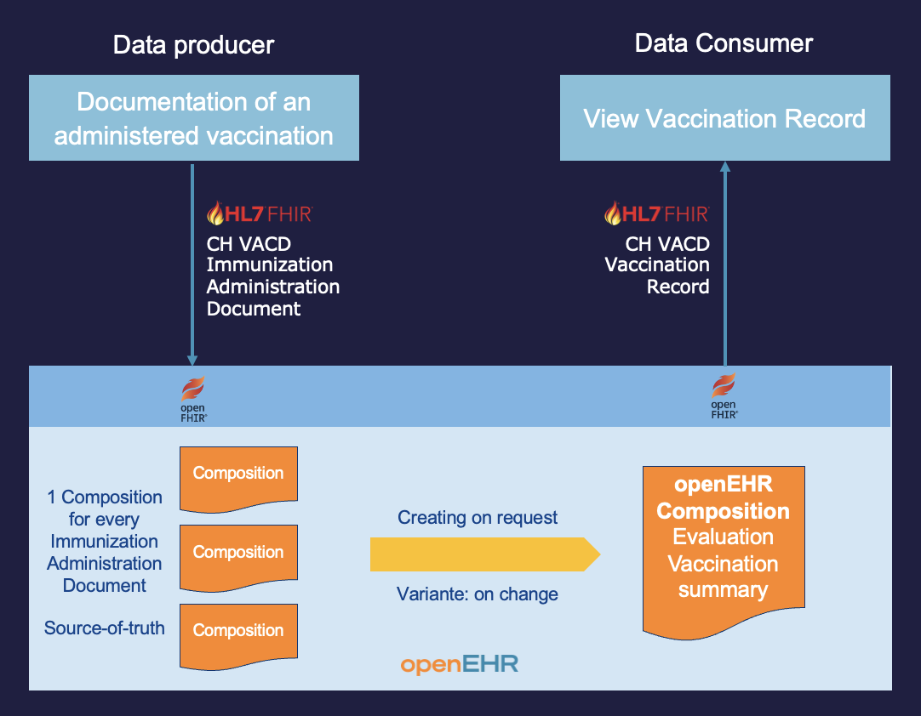
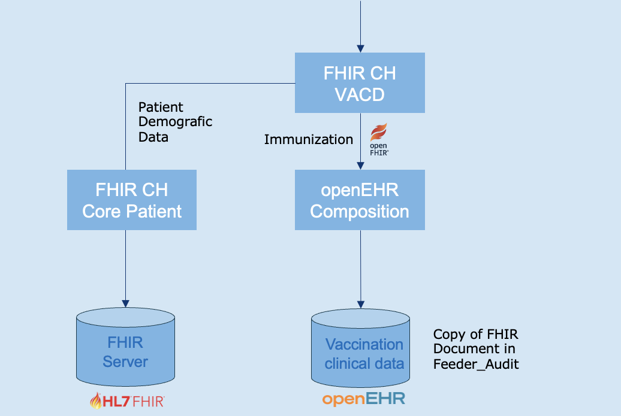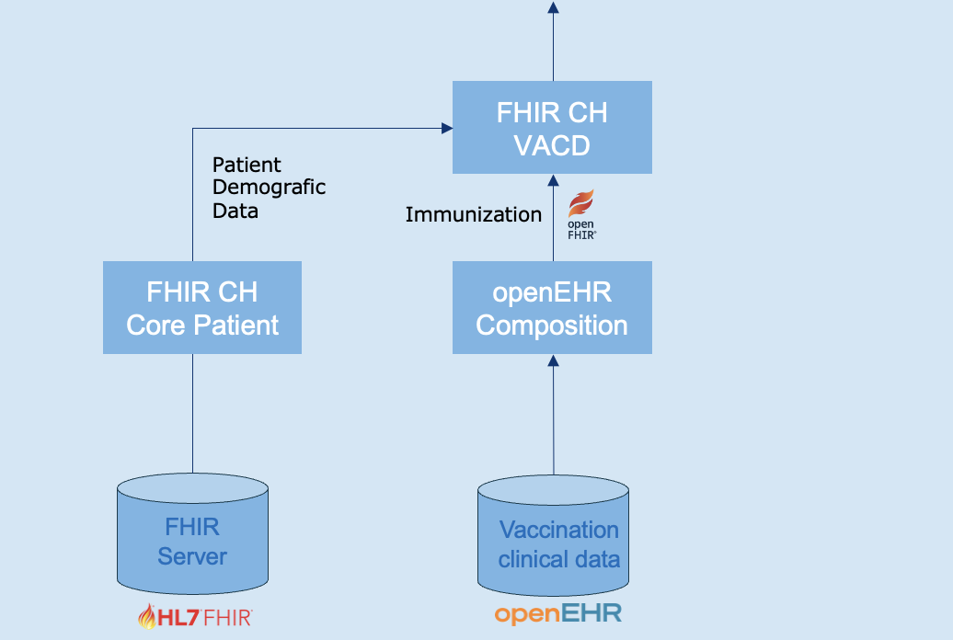

2. Purpose
This document accompanies the Excel mapping table and the openEHR template for CH VACD Immunization Administration. It describes the intended modelling approach used in the showcase for representing vaccination administration data from the FHIR CH VACD Immunization profile in openEHR.
The openEHR template CH VACD Immunization Administration is intended to persist one administered vaccine dose in an openEHR Clinical Data Repository. It is aligned with the FHIR CH VACD Immunization profile and is designed to support the transformation of CH VACD FHIR resources into structured openEHR data.
The initial modelling scope is deliberately limited to:
- the clinically relevant data of one administered immunization
- mandatory CH VACD / FHIR profile elements and elements marked as Must Support (S)
- selected source, provenance and verification information
- retention of the original FHIR source content for traceability
The template is not intended to reproduce the complete FHIR resource structure one-to-one.

3. General modelling principle
The mapping follows a pragmatic separation between clinical content, CH VACD-specific source information and technical FHIR metadata.
- Clinical vaccination content is represented as structured openEHR clinical data. This includes the administered vaccine, administration date and time, route, anatomical administration site, dose information, product details and related clinical comments.
- CH VACD source, verification and provenance information is represented in local CH VACD source-information clusters where structured or queryable access is required. This includes information that is relevant for trust, traceability, validation or reconciliation of the imported immunization entry.
- Technical FHIR metadata and non-core elements are not modelled as clinical openEHR data points in the minimal version. They are retained in feeder_audit / original_content to preserve the original source context.
In the minimal version, the complete source FHIR Immunization document is retained in feeder_audit. Important elements may be extracted separately into feeder_audit or represented in dedicated clusters if structured access is required.

4. Template overview
The openEHR template is structured around one administered vaccine dose. The central clinical entry is ACTION.medication.v1, which represents the actual vaccination administration event.
The template deliberately separates clinical vaccination data from source and technical metadata. Clinical content is represented mainly in the description of ACTION.medication.v1, using the medication action itself and embedded clusters such as CLUSTER.medication.v2, CLUSTER.dosage.v2 and CLUSTER.adverse_reaction_event.v1.
Protocol-related and source-related CH VACD information is represented in the protocol part of ACTION.medication.v1, using dedicated local clusters where appropriate. openEHR Reference Model attributes, such as ACTION.time, careflow state, participation information and feeder_audit, are populated at runtime during Composition creation rather than modelled as ordinary archetyped data elements.
The main structure is:

COMPOSITION.encounter.v1
- category = event
- context
- other_context
- Extension
- content

ACTION.medication.v1
- Reference Model attributes
- ACTION.time
- ACTION.ism_transition / careflow_step
- ACTION.other_participations / performer
- ACTION.other_participations / function
- feeder_audit / original_content
- description
- Vaccine administered
- SLOT Medication details
- CLUSTER.medication.v2 (Medication details)
- Name
- Form
- Manufacturer
- Batch ID / Lot number
- Expiry / Expiration date
- Reason code
- SLOT Amount
- CLUSTER.dosage.v2 (Dosage)
- Dose
- Dose description
- Administration details
- Route
- Body site
- SLOT Additional details
- CLUSTER.adverse_reaction_event.v1 (Adverse reaction event)
- Certainty
- Reaction description
- Onset of reaction
- Supporting clinical record information
- Comment
- Dose number / Sequence number
- Note / Comment
- protocol
- Order ID / Vaccination protocol
- SLOT Extension
- CLUSTER.ch_vacd_immunization_protocol.v0
- Target disease
- Dose potency
- Subpotent dose
- Reason for subpotency
- CLUSTER.ch_vacd_source_information.v0
- Source immunization identifier
- Verification status
- Source data details
- Occurrence data absent reason
- Source recorded date

5. Excel mapping table columns
The Excel mapping table documents the relationship between the FHIR CH VACD Immunization profile and the corresponding openEHR template elements. Each row represents one FHIR field or mapping-relevant FHIR path and describes how it is handled in the openEHR model.

Column | Description
FHIR path | The full FHIR path of the source element, for example Immunization.vaccineCode or Immunization.protocolApplied.targetDisease.
FHIR name | The short FHIR element name as used in the FHIR profile or Snapshot Table, for example vaccineCode, route or targetDisease.
Card. | The cardinality of the FHIR element in the profile, for example 0..1, 1..1 or 0..*. This indicates whether the element is optional, mandatory or repeatable in the FHIR source.
S | Indicates whether the element is marked as Must Support in the FHIR profile Snapshot Table.
Type | The FHIR data type of the element, for example CodeableConcept, Coding, Reference, dateTime, boolean, Identifier or BackboneElement.
FHIR meaning | A short explanation of the meaning of the FHIR element in the context of the CH VACD Immunization profile.
FHIR Value set | The FHIR ValueSet or terminology binding associated with the element, where applicable.
openEHR Archetype / Cluster | The openEHR archetype or cluster used to represent the mapped information, for example ACTION.medication.v1, CLUSTER.medication.v2, CLUSTER.dosage.v2 or a local CH VACD-specific cluster.
openEHR location | The logical location of the target element within the openEHR structure, for example description, protocol, Medication details, Amount, Administration details, feeder_audit or Reference Model.
openEHR element | The original or conceptual openEHR element used for the mapping, often based on the archetype element name.
Target node | The effective target node name in the template. This may differ from the original archetype element name if the element has been renamed in the template.
Template openEHR Path | The template-based openEHR path in dot notation, derived from the WebTemplate IDs. This path is intended as a practical working path for mapping and FHIRconnect-related work.
Template AQL-Path | The corresponding AQL or at-code-based path from the WebTemplate. This path is more robust for openEHR querying and references the archetype IDs and at-codes.
Comment | Additional mapping notes, implementation decisions, transformation rules or limitations.

6. ACTION.medication.v1
ACTION.medication.v1 is used as the main clinical entry for an administered vaccination. An HL7 FHIR CH VACD Immunization Administration Document may contain more than one administered immunization. During conversion from FHIR to openEHR, more than one immunization may therefore be represented using this template structure. For persistence in the openEHR CDR, however, each resulting Composition should represent one administered immunization only.
ACTION.medication.v1 carries the administered vaccine, route, body site, reason code, dose sequence and clinical note. Reference Model attributes are used for the administration time, careflow state, performer participation and feeder audit. Additional details are represented through dedicated clusters inserted into the corresponding ACTION slots.

ACTION.medication.v1

Reference Model attributes populated at runtime
- ACTION.time
(FHIR: Immunization.occurrenceDateTime)
- ACTION.ism_transition / careflow_step fixed to administered
(FHIR: Immunization.status = completed)
- ACTION.other_participations / performer
(FHIR: Immunization.performer.actor)
- ACTION.other_participations / function
(FHIR: Immunization.performer.function)
- feeder_audit / original_content
(FHIR: complete source FHIR Immunization document or source reference)

Description
- Medication item / Vaccine administered
(FHIR: Immunization.vaccineCode)
- Reason code
(FHIR: Immunization.reasonCode)
- Administration details / Route
(FHIR: Immunization.route)
- Administration details / Body site
(FHIR: Immunization.site)
- Dose number / Sequence number
(FHIR: Immunization.protocolApplied.doseNumberPositiveInt)
- Note / Comment
(FHIR: Immunization.note.text)

7. CLUSTER.medication.v2
Medication product details are represented using CLUSTER.medication.v2 within the Medication details slot of ACTION.medication.v1. This cluster is used for generic product-related information about the administered vaccine, such as the product name, pharmaceutical form, manufacturer, batch number and expiry date.
CLUSTER.medication.v2 is not intended to represent the vaccination event itself. The actual administration event remains represented by ACTION.medication.v1.

CLUSTER.medication.v2 / Medication details
- Name / Vaccine product name
(FHIR: Medication.code.text, where available)
- Form
(FHIR: Medication.form, where available)
- Manufacturer
(FHIR: Immunization.manufacturer)
- Batch ID / Lot number
(FHIR: Immunization.lotNumber)
- Expiry / Expiration date
(FHIR: Immunization.expirationDate)

As an interim solution, the Name element may be used to record the official Swiss vaccine trade name from the referenced CH VACD Medication For Immunization resource (Medication.code.text), with the corresponding GTIN code from Medication.code.coding:GTIN retained alongside it where available. https://www.fhir.ch/ig/ch-vacd/StructureDefinition-ch-vacd-medication-for-immunization.html
For a future extended version, CH VACD-specific medication product information from the referenced Medication for Immunization resource may be represented in a dedicated local cluster inserted into CLUSTER.medication.v2 / Structured details, for example:
- CLUSTER.ch_vacd_medication_for_immunization.v0
This local cluster may be used to represent CH VACD-specific product details such as GTIN, product code, product name, pharmaceutical dose form, ingredient codes and ingredient strength.

8. CLUSTER.dosage.v2
The administered vaccine quantity is represented using CLUSTER.dosage.v2 within the Amount slot of ACTION.medication.v1. This cluster is used to record the amount of vaccine administered as part of the vaccination event.
CLUSTER.dosage.v2 is used for the administered dose quantity, not for the dose number within a vaccination series. The dose number or sequence number is represented separately in ACTION.medication.v1.

CLUSTER.dosage.v2 / Dosage
- Dose
(FHIR: Immunization.doseQuantity)
- Dose description

The dose should be represented as a quantity including both numeric value and unit, for example 0.5 mL. A numeric value without a unit is clinically incomplete. Example: Dose = 0.5 mL

9. CLUSTER.adverse_reaction_event.v1
Optional adverse reaction information associated with the administered vaccine may be represented using CLUSTER.adverse_reaction_event.v1 within the Additional details slot of ACTION.medication.v1.
This cluster is used for simple reaction information directly related to the vaccination administration event. It is not intended to replace a complete allergy, intolerance or adverse reaction risk model. Persistent adverse reaction risks, contraindications or legally complete adverse-event documentation should be represented using appropriate dedicated models.

CLUSTER.adverse_reaction_event.v1 / Adverse reaction event
- Certainty
- Reaction description
(FHIR: Immunization.reaction.detail.display, where used as a display or fallback text)
- Onset of reaction
(FHIR: Immunization.reaction.date)
- Supporting clinical record information
(FHIR: Immunization.reaction.detail.reference)
- Comment
Used for additional narrative information about the reaction event.

The FHIR field Immunization.reaction.reported is not mapped to a standard element in CLUSTER.adverse_reaction_event.v1, because the cluster does not contain a simple boolean reported indicator. If required, this value may be retained in feeder_audit or represented in a local extension element.

10. CLUSTER.ch_vacd_immunization_protocol.v0
CH VACD-specific immunization protocol information is represented using the local cluster CLUSTER.ch_vacd_immunization_protocol.v0 within the Extension slot of the protocol part of ACTION.medication.v1.
This cluster is used for information related to the vaccination protocol or schedule, rather than for the administered vaccine product, dose quantity, route, body site or source metadata.
In the current version, only the most relevant protocol-related fields are included. Additional CH VACD protocol fields may be added later if they need to be accessed directly, displayed in applications or queried independently from the original FHIR source content.

CLUSTER.ch_vacd_immunization_protocol.v0
- Target disease
(FHIR: Immunization.protocolApplied.targetDisease)
- Dose potency
- Subpotent dose
(FHIR: Immunization.isSubpotent)
- Reason for subpotency
(FHIR: Immunization.subpotentReason)

Target disease represents the vaccine-preventable disease or condition that the administered vaccine is intended to protect against. Where possible, it should be coded using the CH VACD target disease value set.
Dose potency is used to record whether the administered vaccine dose is considered subpotent and, if applicable, the reason for reduced potency. This information should not be confused with the administered dose quantity, which is represented using CLUSTER.dosage.v2.

11. CLUSTER.ch_vacd_source_information.v0
CH VACD-specific source, provenance, verification and data-quality information is represented using the local cluster CLUSTER.ch_vacd_source_information.v0 within the Extension slot of the protocol part of ACTION.medication.v1.
This cluster is used for information about the origin, trustworthiness, traceability and completeness of the source immunization data. It is not used for the clinical vaccination content itself. The administered vaccine, administration time, route, body site, dose quantity and product details are represented in ACTION.medication.v1 and the corresponding clinical clusters.
In the current version, only the most relevant source-related fields are included. Additional CH VACD source, provenance or data-quality fields may be added later if they need to be accessed directly, displayed in applications or queried independently from the original FHIR source content.

CLUSTER.ch_vacd_source_information.v0
- Source immunization identifier
(FHIR: Immunization.identifier)
- Verification status
(FHIR: Immunization.extension:verificationStatus)
- Source data details
- Occurrence data absent reason
(FHIR: Immunization.occurrenceDateTime.extension:data-absent-reason)
- Source recorded date
(FHIR: Immunization.recorded)

Verification status indicates the verification state of the CH VACD immunization source information. This field is mandatory in the FHIR CH VACD Immunization profile and is therefore represented explicitly in the local source information cluster.
Source immunization identifier is used for traceability, matching or reconciliation of imported immunization entries.
Occurrence data absent reason explains why the structured vaccination administration date or time is missing, if applicable. It is source data-quality information and must not be confused with the vaccination administration time itself.
Source recorded date represents the date and time when the source immunization entry was first recorded in the source system. It is not the vaccination administration time and not the openEHR commit time.
The complete original FHIR source content should still be retained in feeder_audit / original_content for traceability, even when selected source fields are represented structurally in this cluster.

12. Performer and encounter context
The performer of the vaccination may be represented using the openEHR Reference Model. Preferred mapping for the performer of the specific vaccination event:
Immunization.performer.actor
-> ACTION.medication.v1 / other_participations / performer
Immunization.performer.function
-> ACTION.medication.v1 / other_participations / function
If the implementation or tooling does not support ACTION-level participations, COMPOSITION.context.participations may be used as a pragmatic fallback.
Immunization.encounter should usually be mapped to COMPOSITION.context, where the referenced FHIR Encounter can be resolved. If it cannot be resolved, the original FHIR reference should be retained in feeder_audit or in a source/provenance structure.

13. Status handling
This template is intended for administered vaccinations. The original FHIR Immunization.status is retained as part of the complete source FHIR Immunization content in feeder_audit / original_content for traceability.
At the level of structured openEHR data fields, the following transformation logic applies:

FHIR Immunization.status = completed
-> transform as administered vaccination
FHIR Immunization.status = not-done
-> out of scope for this template
FHIR Immunization.status = entered-in-error
-> handle via correction / invalidation process

The openEHR ACTION.medication.v1 / ism_transition / careflow_step should be fixed or set at runtime to represent an administered dose.

14. Cardinality considerations
Some FHIR elements allow multiple occurrences, whereas the corresponding openEHR template element may currently be constrained to a single occurrence.
FHIR Immunization.note is 0..*
openEHR Comment may be constrained to 0..1
FHIR Immunization.reasonCode is 0..*
openEHR Reason code / Clinical indication may be constrained to 0..1
For these cases, either the openEHR template cardinality should be relaxed where possible, or a transformation rule should be defined, for example concatenating multiple notes or selecting a primary reason.

15. Terminology binding
FHIR ValueSets are used as the basis for terminology bindings where applicable. In the Archetype Designer, the value sets may be referenced using FHIR terminology expansion URLs, for example via the Swiss FHIR terminology server:
https://tx.fhir.ch/r4/ValueSet/$expand?url=<canonical-ValueSet-URL>&_format=json
Terminology-bound fields should preferably be constrained to DV_CODED_TEXT in the template where possible, even if the base archetype element was initially modelled as text.

16. Known limitations of the initial version
The current template is a minimal clinical and CH VACD-aligned representation. The following aspects are intentionally limited or deferred:

- complete modelling of all FHIR Snapshot Table fields
- full FHIR CH VACD Medication for Immunization product model
- modelling of the FHIR CH VACD Basic Immunization profile https://www.fhir.ch/ig/ch-vacd/StructureDefinition-ch-vacd-basic-immunization.html
- complete modelling of adverse vaccination reactions
- complete vaccination record
- non-administration, refusal or contraindication workflows
- full document-level CH VACD / XDS metadata modelling

The FHIR CH VACD Basic Immunization profile is not yet covered in the current openEHR template. This profile is used to document a declared basic immunization as a Condition, for example when a patient has no vaccination certificate or when not all individual vaccinations can be entered due to missing documentation, but it is known that the basic immunization has been completed. This aspect should be added in a later iteration, either by extending the current model or by defining a separate openEHR representation for basic immunization declarations.
These aspects can be added in later iterations using additional local clusters, additional templates or separate openEHR compositions.

